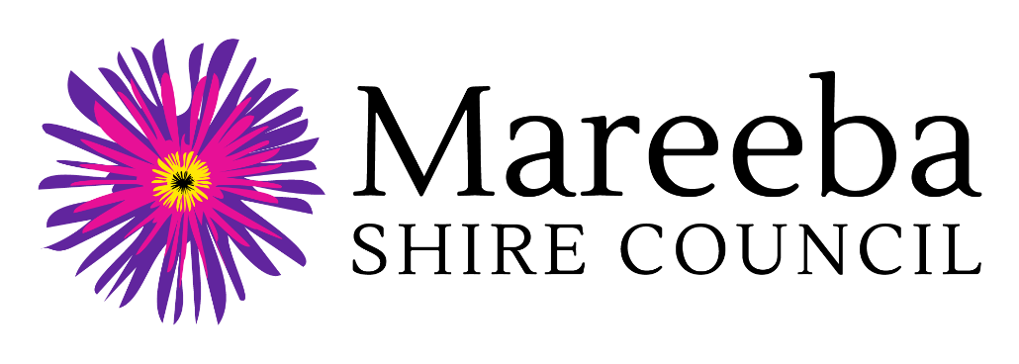
Regional Arts Development Fund (RADF) 2021-22

Community Grant Application Form

Applicant Name:
Project Name:
RADF Community Grant Amount Requested:

Personal Information Collection Notice
Mareeba Shire Council is collecting your personal information for the purpose of assessing and processing of your application for funding under the Regional Arts Development Fund and if your application is successful, administering the grant funding. Information will be disclosed to Arts Queensland and where deemed necessary, may be used by Council to contact other agencies to verify their support of and / or involvement in the project. The information may additionally be used for reporting purposes and to support publicising and promoting the objectives of the Regional Arts Development Fund. Your personal information will be handled in accordance with the provisions contained within the Information Privacy Act 2009 (Qld).

Human Rights Compatibility Statement
The Human Rights Act 2019 came into effect on 1 January 2020 and will mean fairer laws, policies and practices by public entities when dealing with the community on a day-to-day basis. Council holds an obligation under the Human Rights Act 2019 to make decisions and act in a way compatible with human rights. Council is committed to building a culture that respects and promotes human rights and we will give proper consideration to, and act compatibly with, human rights in our work and daily interaction with all persons.
Regional Arts Development Fund 2021-22
Community Grant Application Form

General Instructions
- All applicants requesting RADF funding are required to submit an application on or before the closing date.
- Please read Mareeba Shire Council's RADF 2021-22 Guidelines for Community Grant Applications that are available on the Council website www.msc.qld.gov.au/grants-and-sponsorship/ before completing the application.
- Mark your response to checklists with an "x" or insert a symbol.
- Return your completed application and supporting material to Mareeba Shire Council's RADF Officer by post, email or in person. Lodgement details are located at Section 5.
1. Applicant Information

1.1 Applicant Details
Refer to Section 4 of the RADF 2021-22 Community Grant Guidelines
Applicant Type: (please select one)
 | An individual |  |  | A group or unincorporated organisation
 | An incorporated not-for-profit organisation |  |  | An arts or cultural company
Applicant Name:
Contact Person Name:
Position in Organisation:
Street Address:
Postal Address:
Telephone / Mobile:
Email Address:

1.2 Australian Business Number and GST Registration
Refer to Sections 11 & 14 of the RADF 2021-22 Community Grant Guidelines
Do you have an Australian Business Number (ABN): |  |  |  |  | Yes |  | No
If yes, | ABN:
Registered Business Name:
Are you Registered for GST: |  |  |  |  | Yes |  | No
Successful applicants who do not have an ABN, will be required to complete a Statement by a Supplier Form.

1.3 RADF Grant History
Refer to Sections 4 & 13 of the RADF 2021-22 Community Grant Guidelines
Have you or your group previously applied for a RADF grant? |  | Yes |  | No
If successful, have your RADF grants been successfully acquitted? |  | Yes |  | No
2. Project Details

2.1 Project Information
Refer to Sections 4 & 5 of the RADF 2021-22 Community Grant Guidelines
Project Name:
Project Brief Description:
Total project budget ($):
RADF grant requested ($):
Project Start Date:
Project Completion Date:
In which locations (towns) will the project activities be undertaken?

2.2 Project Type
Refer to Section 6 of the RADF 2021-22 Community Grant Guidelines
Please select one Project Type that best describes the activities to be delivered:
 | Consultation, research, policy development |  | Performances
 | Development and promotion of new work |  | Place-making
 | Cultural tourism |  | Professional development activity
 | Events and Festivals |  | Publications
 | Exhibitions and Collections |  | Workshops
 | Heritage Protection and Promotion |  | Other:

2.3 Project Description
Refer to Sections 1-8 & 13 of the RADF 2021-22 Community Grant Guidelines
Please provide a comprehensive description of your project, using the subheadings below:
(Maximum 600 words)
1. Aims and Objectives
2. Activities and Timeframe
3. Project Facilitators / Volunteers / Other Partners
4. Participants and / or Audiences
5. Locations
6. Other Project Details
7. Expected Outcomes

2.4 Response to RADF Objectives and Local Priorities
Refer to Sections 2 & 3 of the RADF 2021-22 Community Grant Guidelines
To which local priority or RADF objective, does your project best respond? Select one only
Youth engagement in arts and culture
Cultural tourism
Public mural partnerships
Build local cultural capacity, cultural innovation and community wellbeing
How will project outcomes support RADF objectives and / or local priorities. (Max 300 words).

2.5 Project Reporting
Refer to Section 17 of the RADF 2021-22 Community Grant Guidelines
I am confident that if this project is funded by RADF, then I will be able to complete the RADF Project Outcome Report. |  | Yes |  | No

2.6 Safety and Permissions
Refer to Section 15 of the RADF 2021-22 Community Grant Guidelines
Please outline how you will address the issues of risk management, public liability insurance, and obtaining other relevant licences and permissions. Max 200 words.

2.7 Project Budget
Refer to Section 11 of the RADF 2021-22 Community Grant Guidelines
1. INCOME |  |  | 2. EXPENSES
1A. RADF Grant Requested |  |  | 2A. Salaries, Fees, Allowances
- RADF grant requested | $ |  |  | $
 |  |  |  | $
 |  |  |  | $
 |  |  |  | $
1B. Cash Contributions from Applicant |  |  | 2B. Travel / Accomm / Venue Hire
 | $ |  |  | $
 | $ |  |  | $
 | $ |  |  | $
 | $ |  |  | $
1C. Cash Contributions from Other Sources (Sales, Fees, Grants, Donations) |  |  | 2C. Materials / Equipment & Other Project Costs
 | $ |  |  | $
 | $ |  |  | $
 | $ |  |  | $
 | $ |  |  | $
1D. In-Kind Contributions (Donations, Voluntary Labour, Discounts) |  |  | 2D. Administration / Insurance & Permits / Advertising
 | $ |  |  | $
 | $ |  |  | $
 | $ |  |  | $
 | $ |  |  | $
1E. TOTAL INCOME | $ |  | 2E. TOTAL EXPENSES | $

Please note that 1E. Total Income must equal 2E. Total Expenses
Please list which expenses will be paid from the RADF grant.
3. Support Material
Refer to Section 12 of the RADF 2021-22 Community Grant Guidelines
List any support materials that you are including with your application.
4. Applicant Agreement
Please read each statement below and sign to confirm your acknowledgement and agreement of these terms:
- If the applicant is a group or organisation, I certify that I have appropriate delegation, as authorised by the applicant, to prepare and submit this application on behalf of the applicant.
- I have read Mareeba Shire Council's RADF Guidelines for Community Grants Applications and certify to the best of my knowledge the information provided in this form is correct and discloses full and accurate information of proposed income, expenditure and activities.
- I understand that if Mareeba Shire Council approves this grant application, I will be required to accept the conditions of the grant outlined in MSC Guidelines for Community Grant Applications 2021-22.
- I agree to grant Arts Queensland and Mareeba Shire Council an irrevocable, royalty-free licence, to enable Arts Queensland and Mareeba Shire Council, to use work produced in accordance with the RADF Program, for the purposes of publicising the RADF Program or promoting Queensland’s arts and culture.
- I understand that use of my work by Arts Queensland and Mareeba Shire Council for the purposes of publicising the RADF Program or promoting Queensland’s arts and culture, does not infringe my Moral Rights.
- I understand that Arts Queensland and Mareeba Shire Council acknowledge and agree that Intellectual Property Rights in works created by a RADF recipient, will not transfer to either Arts Queensland or Mareeba Shire Council as a result of this Agreement.
- I understand that Mareeba Shire Council and Arts Queensland treat all personal information received and collected in accordance with the Information Privacy Act 2009.
- I understand that the provisions of the Right to Information Act 2009 apply to documents in the possession of Arts Queensland and Mareeba Shire Council.

Signature: |  |  | Date:
Name in Full:
Position in Organisation (if applicable):
If you are under 18 years of age your legal guardian must also sign this application
Guardian Signature: |  |  | Date:
Name in Full:
5. LODGEMENT AND CLOSING DATE
Please return your completed RADF Application Form to Mareeba Shire Council by Monday 14 March 2022. Applications, including supporting material, may be submitted by one of the following methods:
- Post: Coordinator Community Services, Mareeba Shire Council, PO Box 154, Mareeba Q 4880
- In person: Mareeba Shire Council, 65 Rankin Street, Mareeba Q 4880
- Email: info@msc.qld.gov.au

For further information please contact Coordinator Community Services, Mareeba Shire Council:
- Telephone: 1300 308 461 or 4086 4695
- Email: info@msc.qld.gov.au

