Mareeba Shire Council

Subordinate Local Law No. 5
(Parking) 2018

Mareeba Shire Council
Subordinate Local Law No. 5 (Parking) 2018

Contents

Part 1 Preliminary .......................................................................................... 2

1 Short title .............................................................................................................. 2

2 Purpose and how it is to be achieved .................................................................. 2

3 Authorising local law ............................................................................................ 2

4 Definitions............................................................................................................. 2

Part 2 Declaration of parking areas for the TORUM Act ............................ 2

5 Declaration of traffic areas—Authorising local law, s 5........................................ 2

6 Declaration of off-street regulated parking areas—Authorising local law, s 6 ..... 2

Part 3 Parking contrary to parking restriction ............................................ 3

7 Parking permits issued by local government—Authorising local law, s 7(2) ....... 3

Part 4 Minor traffic offence infringement notice penalties......................... 3

8 Infringement notice penalty amounts—Authorising local law, s 9........................ 3

Part 5 Miscellaneous ..................................................................................... 3

Schedule 1 Declaration of traffic areas ................................................................ 4

Schedule 2 Declaration of off-street regulated parking areas ............................ 7

Schedule 3 Infringement notice penalty amounts for certain minor traffic offences............................................................................................... 9

Part 1 Preliminary

1 Short title

This subordinate local law may be cited as Subordinate Local Law No. 5 (Parking) 2018.
2 Purpose and how it is to be achieved

(1) The purpose of this subordinate local law is to supplement Local Law No. 5 (Parking)
2018, which provides for the exercise of local government powers authorised under the TORUM Act.

(2) The purpose is to be achieved by providing for—

(a) the establishment of traffic areas and off-street regulated parking areas; and

(b) the persons who may be issued with parking permits and the terms and conditions of such permits; and

(c) the vehicles that can be issued with commercial vehicle identification labels;
and

(d) the infringement notice penalty amounts for minor traffic offences.
3 Authorising local law

The making of the provisions in this subordinate local law is authorised by Local Law
No. 5 (Parking) 2018 (the authorising local law).
4 Definitions

Particular words used in this subordinate local law have the same meaning as provided for in the authorising local law.
Part 2 Declaration of parking areas for the TORUM Act
5 Declaration of traffic areas—Authorising local law, s 5

(1) For section 5(1) of the authorising local law, the whole local government area is declared to be a traffic area.

(2) For section 5(2) of the authorising local law, the boundaries of the traffic area is indicated by bold lines circumscribing the hatched areas on the maps in schedule 1.
6 Declaration of off-street regulated parking areas—Authorising local law, s 6

(1) For section 6(1) of the authorising local law, each area of land indicated by hatching in the maps in schedule 2 is declared to be an off-street regulated parking area.

(2) For section 6(2) of the authorising local law, the boundaries of each off-street regulated parking area are indicated by the lines circumscribing the hatched areas on the maps in schedule 2.

Part 3 Parking contrary to parking restriction
7 Parking permits issued by local government—Authorising local law, s 7(2)
For section 7(2) of the authorising local law, a person may be issued with a parking permit mentioned in section 7(1)(b) of the authorising local law if—

(a) the person is engaged in a temporary activity that—

(i) affects premises adjacent to a designated parking space to which the application for a permit relates; or

(ii) requires the use of a designated parking space for a charitable or community benefit purpose; and

(b) the person cannot reasonably carry out the activity unless the designated parking space is allocated to the person’s exclusive use for the duration of the activity.
Part 4 Minor traffic offence infringement notice penalties
8 Infringement notice penalty amounts—Authorising local law, s 9
For section 9 of the authorising local law, the infringement notice penalty amount for an offence mentioned in column 1 of schedule 3 is the corresponding amount stated in column 2 of schedule 3.
Part 5 Miscellaneous

This part in the authorising local law does not contain any matters to be provided for by subordinate local law.

Schedule 1 Declaration of traffic area

section 5

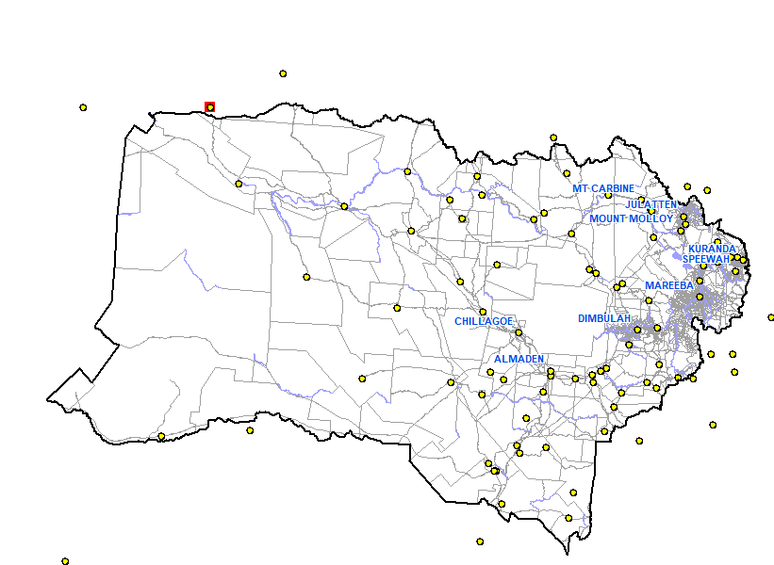

Schedule 2 Declaration of off-street regulated parking areas

section 6

Mareeba Off Street Parking Area

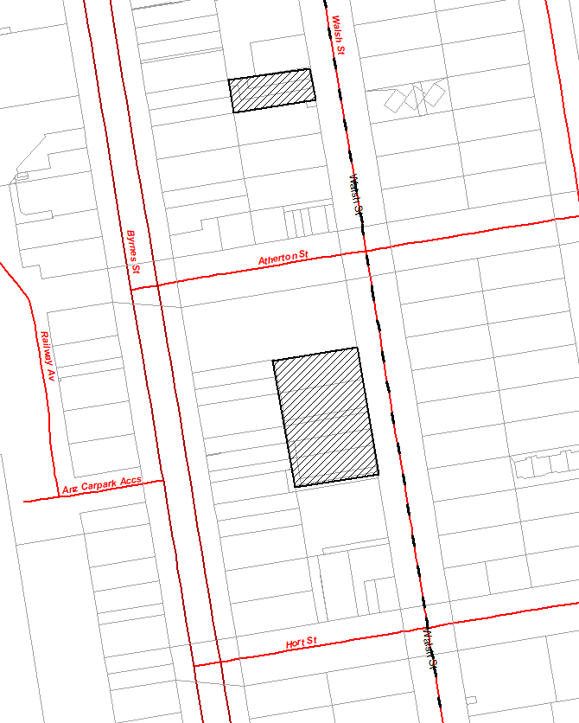

100
Meters

Kuranda Off Street Parking Area

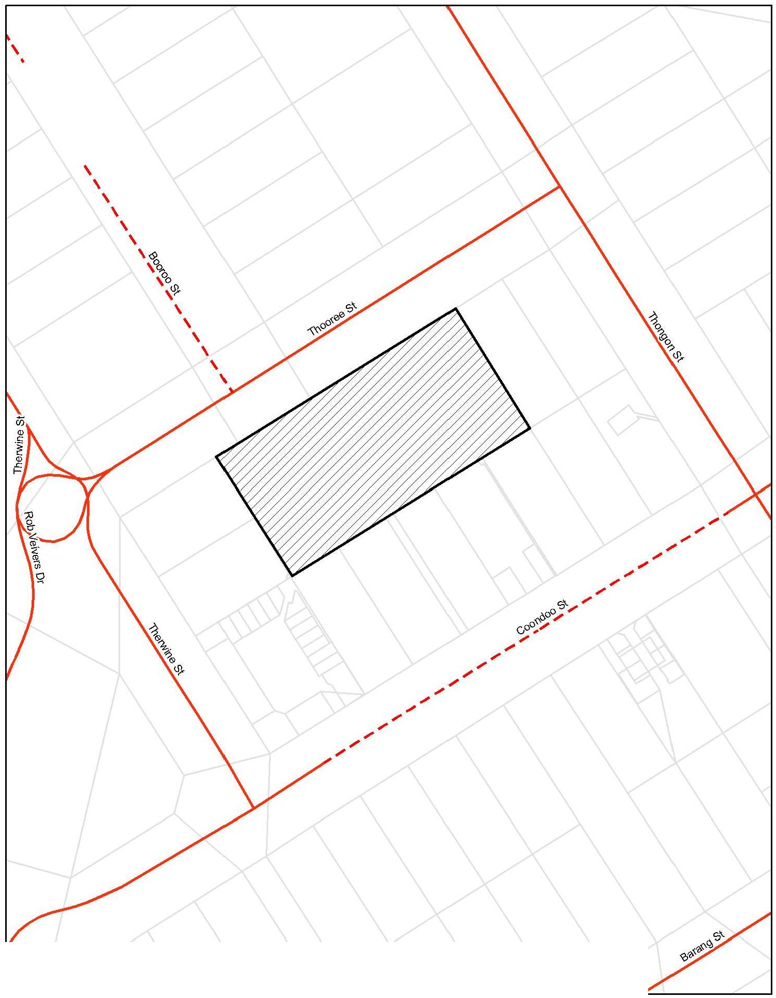

50 100
Meters

Schedule 3 Infringement notice penalty amounts for certain minor traffic offences

section 8

1
Column 1  Minor traffic offence | Column 2  Infringement notice penalty amount
Paid parking offences provided for in section 106 (Paid parking offences) of the Transport Operations (Road Use Management) Act 1995 | 0.3 penalty unit
The offence provided for in section 203 (Stopping in a parking area for people with disabilities) of the Transport Operations (Road Use Management –Road Rules) Regulation 2009 | 2 penalty units
Offences related to loading zones provided for in section  179 (Stopping in a loading zone) of the Transport Operations (Road Use Management – Road Rules) Regulation 2009 | 0.5 penalty unit
Other parking offences provided for in part 12 (Restrictions on stopping and parking) of the Transport Operations (Road Use Management –Road Rules) Regulation 2009 | 0.3 penalty unit
All other offences which relate to the parking or stopping of a vehicle as provided for in section 74 (Contravention of official traffic sign an offence) of the Transport Operations (Road Use Management) Act 1995 | 0.3 penalty unit

2

3

4

5

